* If the chi-squared value is **GREATER** **THAN** the critical value, ______________________________ the null hypothesis!
* If the chi-squared value is **LESS THAN** than the critical value, ______________________________ the null hypothesis!

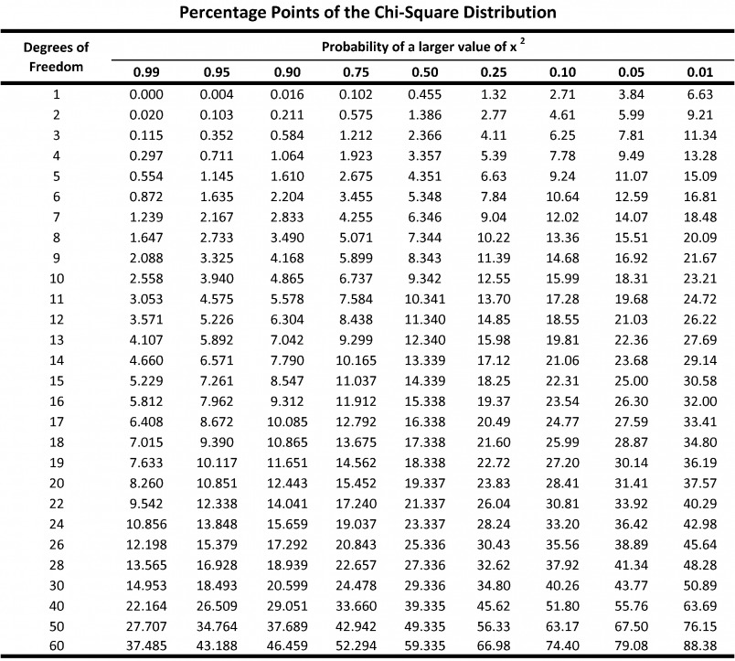

* Failing to reject the null hypothesis means there is NO statistically significance difference between the observed and expected values.
* Rejecting the null hypothesis means there IS a statistically significance difference between the observed and expected values. You will need to attempt to explain why there is a difference using research/background knowledge!